UPDATES TO TALENT STUDIO OCTOBER 2008

Additional Column added to My Team

New Print Functionality for Portfolio Items

Flexi Placement Manager Evaluations

Academic Record

Leave Request and Entitlement form

Speed Improvements

Portfolio requests (questionnaires) retain edits – no need to Save.

Changes to Report Results

Additional Column added to My Team

Placement, Programme and Leadership Development Managers will notice an additional column when viewing My Team. The additional column displays Intake Year and will help those of you with large teams distinguish quickly between trainees of different years and managers.

You will also notice that the Browse function only becomes available once you have clicked on a team member. This should speed up the display of the My Team.

New Print Functionality for Portfolio Items

Each request in the portfolio now has an Export to PDF option.

To use this open up a form in View mode; click on the Export to PDF link; a new window will open that displays the form in a print friendly version.

You then have the option to print or save the document.

Flexi Placement Manager Evaluations

Where a Flexi Placement Manager has completed a feedback form it will be available near the top of the trainee Portfolio in a section called Requests/ Review.

The reason why it is in a different place to the rest of the Portfolio forms is that Flexi Placement Managers have a different type of Talent Studio access to other managers.

It will not display at all if the Flexi Placement Manager has not completed the form.

Academic Record

A form called Academic Record has now been added to the trainee Portfolio in the group called Performance. This form is used to display exam/ assignment results and is particular to each specialism.

Results are entered on to the form as the results become available from the education providers along with any comments relating to the results.

Results from 2007 are being uploaded and should be available, if not now, in the very near future.

Leave Request and Entitlement form

As a result of removing the Attendance Record and the need to improve the current form, The Leave Request and the Annual Leave entitlement forms have been combined.

This allows all users to see how much leave a trainee is entitled to and how much leave they have taken.

The form states what the current basic entitlement is and it allows LDMs or area office administrators to enter any additional entitlements or carried over leave balances. These fields cannot be edited by trainees.

Please note that automatic calculations are not possible on this form.

2007 Trainees:

Your current Leave Request form has been closed for entry. For all occurrences of leave from September 2008 onwards please use the new Leave Request and Annual Entitlement.

Any leave requests for the period September 2008 onwards will be transferred over to this new form. Please check that this has been done.

How the form works:

Trainees:

§ Enter the details for your leave request in the appropriate period. There is a separate group for each leave period.
§ To add a new request for a certain time period click Add to add a new row.
§ Use the date pickers to add your start and end dates, and then state how many days you are requesting. Remember not to include Bank Holidays or weekends in your number of days requested.
§ Then state the new balance of your leave entitlement for that period.
§ Once complete you can use the Send Email Notification or Send to Talent Studio Inbox to inform your managers that you have requested leave.
.
Managers:

§ To approve leave you need to
§ select the date of authorisation
§ add your name to the ‘Authorised By’.
§ Please then check the box in the enable/Disable Row column. This means that the row is locked for editing and the leave request cannot be altered.

To edit a leave request:

If a leave request needs updating once it has been approved by the manager, a manager needs to uncheck the box in the Enable/Disable Row column, make the updates and then lock the row again by re-checking the box. If the leave is not taken at all once approved the manager can just delete the row.

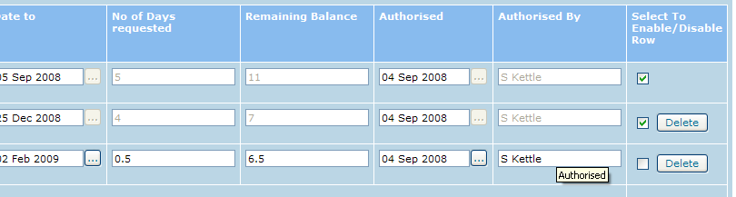

Area Offices/ Administrators

The top section of the form allows entry of any additional entitlements or approved carried over leave from a previous leave year.

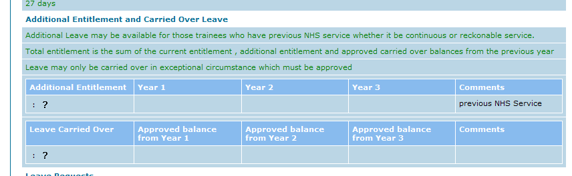

Speed Improvements

Users should notice that the time taken to log in decreases dramatically. A lot of the background work that used to happen during log in such as getting user’s security permissions now happens as a separate activity – you will see a message at the top of the screen after log in that will show you if this activity is still in progress and this may affect the speed of some actions until this is complete.

Portfolio requests (questionnaires) retain edits – no need to Save.

You will not need to worry about system time outs or loss of network…..

Edist to questionnaires will now be retained automatically without the need to Save. Because of this the Save button has been removed and the user has the option to close the questionnaire by selecting Close.

If the user wishes to use the Email Notification or Talent Studio Inbox functions they need to select the desired option and select Send instead of selecting Close.

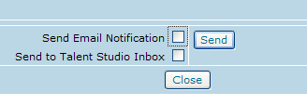

Changes to Report Results – affects LDMs and other scheme staff users

Reports will now run much faster due to the introduction of result pagination. 25 results will display per page. Previously all results were presented on a single page.

